**Big Mountain market analysis report and recommendations for profitability:**

An analysis of Big Mountain Ski Resort facilities and ticket prices suggest profits can be increased through cutting unpopular facilities, investing in valuable facilities, and an upward adjustment of the ticket price. Based on price modeling and analysis of Big Mountain’s position in the market, a modest price increase by less than $2 combined with removal of two or more runs would improve value to customers and profitability.

**Data Sources and Descriptions**

Our data contains information on 279 United States ski resorts, covering the geographic area and topographic attributes, information on numbers and types of lifts and chairs, the numbers and types of runs, daytime and nighttime skiable area in acres, snow-making capacity, operational days, and adult weekend ticket pricing (Fig. 3). Additional data was added pertaining to state population and area. Average values by state are included for number of resorts and total area of some features along with calculated ratios of each resort’s share of the state’s market.

**Results:** Data visualizations suggest relationships between ticket price and several variables (Fig. 3). We’ll focus on features that can be changed. An increase in any chair type may positively influence ticket price; the steep distribution for total chairs supports this. Vertical drop, total runs, longest run, snow-making, availability of night skiing, skiable terrain and days open are features showing promise for increased ticket value.

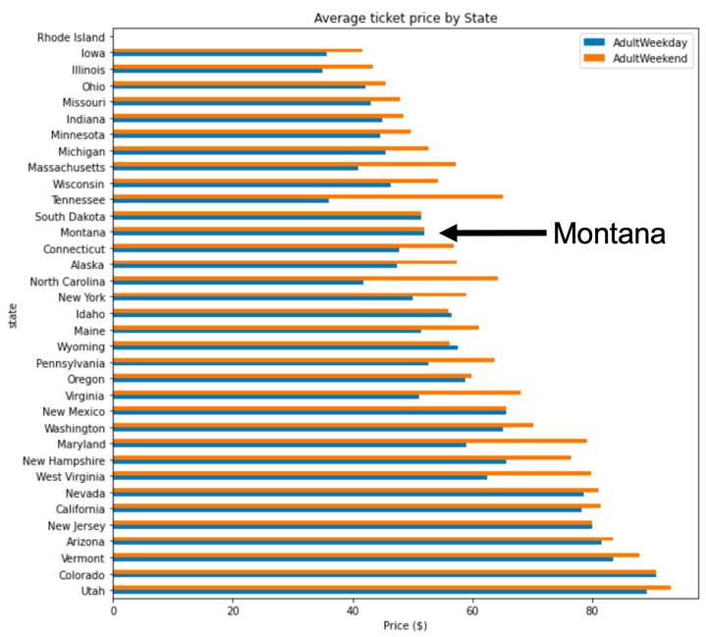

Fig. 1. Average weekend and weekday ticket for resorts by state.

**Ticket price adjustment:** Our model predicts ticket value based on measured values for each feature across the market. Prices at Big Mountain could be raised a minimum of $1.30 and a maximum of $22 per ticket. While Big Mountain ticket price is high for the state of Montana, price was not limited by state across the US market. Big Mountain’s skiable features rank high nationally and in Montana. A localized study of Montana as well as nearby states may point to gaps in services in the local (Montana) and nearby market. Addressing lack of service in these areas could justify a higher ticket price.

**Facility improvement:** A recently installed lift increased annual operating costs by $1.54M. A price increase of $0.88 covers this additional cost. The addition of a new lift calls for another upward adjustment of $0.88 to cover costs and increases the ticket value for customers by $0.54. Adding a new chair lift will increase ticket value enough to cover 63% of the additional operating cost, leaving a gap of approximately $555k to be covered elsewhere.

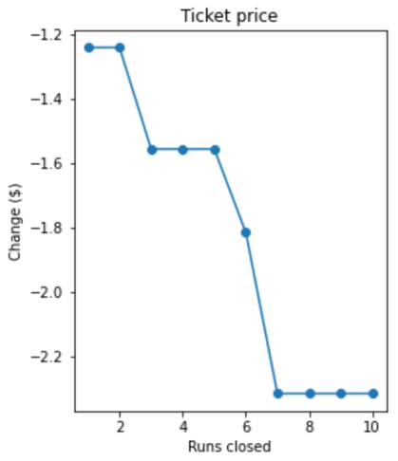

**Run-closures:** Closing two runs will have little impact on ticket value and will provide a good baseline for customer reaction to further reducing ski runs. Information of the costs of maintaining the 10 least-used runs was not available for estimating the cost savings.

Fig. 1. Change in ticket value with reduction of runs

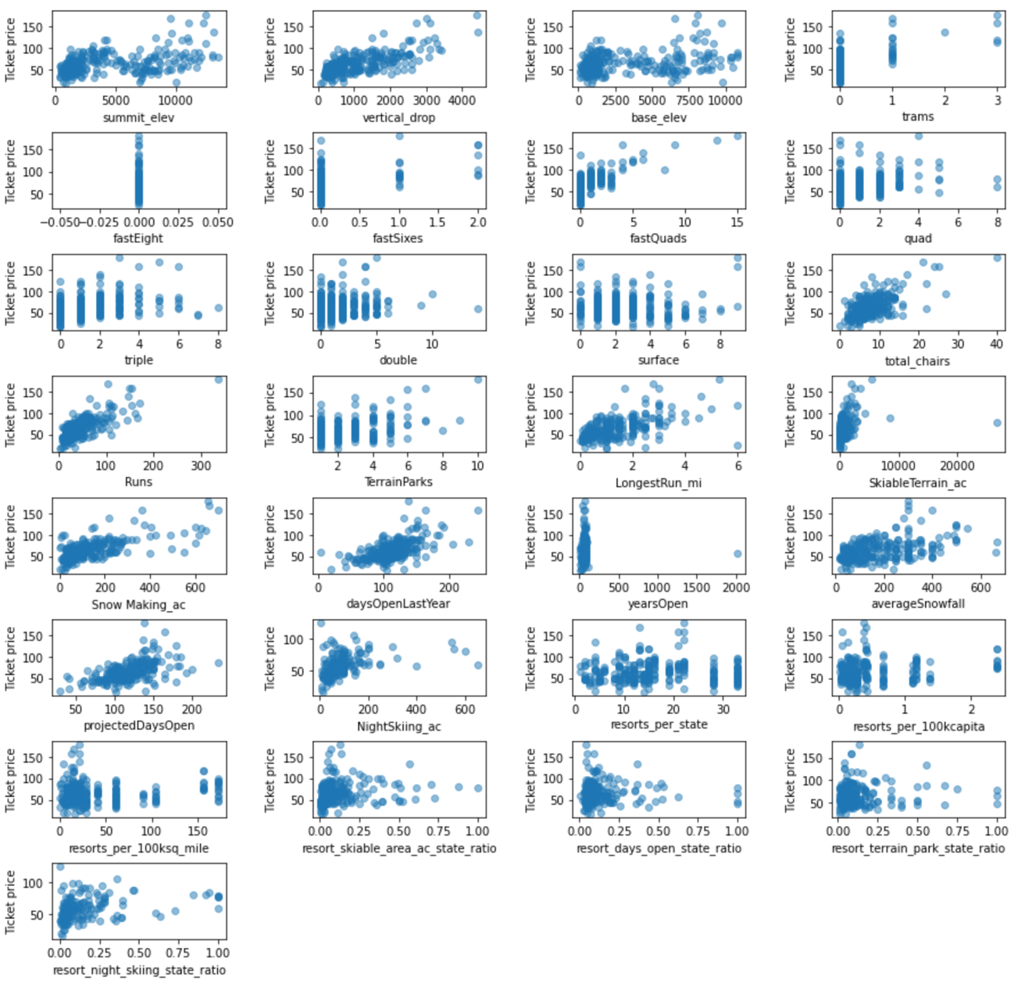

Fig. 2. Scatterplots for US resorts with ticket price on y-axis and features on x-axis.